**Assignment 3 : Retrieve data using Group By clause.**

Create table:-

Create table [Department](

dept_id int Primary Key Identity(1,1),

dept_name varchar(50)

);

Create table [Employee](

emp_id int Primary Key Identity(1,1),

dept_id int Foreign key references Department(dept_id),

mngr_id int not null,

emp_name varchar(25) not null,

salary float not null

);

Insert Rows query:-

insert into Department values ('.net'),('java'),('nodejs'),

('Fianance'),('Mobile Application'),('networking');

insert into Employee values ( 1,2001,'keyur',30000),( 1,2010,'ketul',60000),( 2,2001,'Tina',25000),

( 2,2003,'bina',30000),( 2,2003,'Aadity',45000),( 3,2002,'Ayan',47000),( 3,2002,'kenil',50000),

( 4,2004,'sita',60000),( 4,2004,'binesh',55000),( 5,2005,'feny',60000),( 5,2005,'foram',67000),

( 6,2006,'vimal',40000),( 6,2006,'vinit',30000);

**1. write a SQL query to find Employees who have the biggest salary in their Department.**

**Ans:-**

with maximum_salary_table as(select max(Salary) as Salary, dept_id from Employee group by dept_id)

select e.emp_name 'Employee',d.dept_name 'Department name', e.Salary 'Max Salary' from Employee e join Department d

on e.dept_id = d.dept_id

join maximum_salary_table m on e.Salary = m.Salary and e.dept_id = m.dept_id;

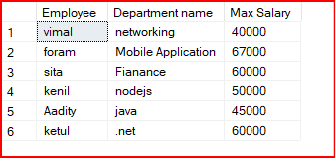Output:-

**2. write a SQL query to find Departments that have less than 3 people in it**

**Ans:-**

select d.dept_name 'Departments' from Department d left join Employee e on d.dept_id=e.dept_id

group by e.dept_id,d.dept_name

having COUNT(e.dept_id)<3;

**OutPut:-**

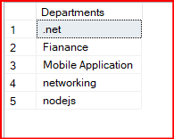

**3. write a SQL query to find All Department along with the number of people there.**

**Ans:-**

select d.dept_name 'Departments' , COUNT(e.dept_id) 'Number of people' from Department d left join Employee e on d.dept_id=e.dept_id

group by e.dept_id,d.dept_name;

**OutPut:-**

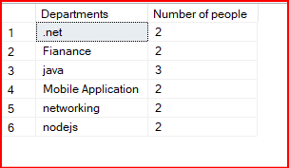

**4. write a SQL query to find All Department along with the total salary there.**

**Ans:-**

select d.dept_name 'Departments' , sum(e.salary) 'Total Salary' from Department d left join Employee e on d.dept_id=e.dept_id

group by e.dept_id,d.dept_name;

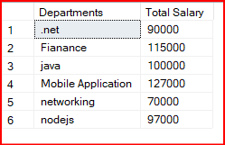**Output:-**